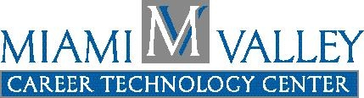

Miami Valley Career Technology Center Press Release

For Further Information Contact:
Kelly Herzog
MVCTC Public Information Coordinator
Phone - 937-854-6056
E-Mail – kherzog@mvctc.com

For Immediate Release – August 2008

MVCTC Culinary Arts Students Participate in “The Great American Bake Sale”

Clayton, Ohio - Miami Valley Career Technology Center (MVCTC) Culinary Art seniors heard about the Great American Bake Sale, a nationwide fund-raiser sponsored by “Share Our Strength” and made the decision to get involved! The students dedicated part of their summer vacation to gathering donations from local businesses to bake over 150 dozen cookies that were sold at the MVCTC Schedule Pick-up event in early August. They were successful in earning over $800 that was donated to “Share Our Strength”, a national organization working to make sure no kid in America grows up hungry. It was a great community service project as well as a project that relates to their Culinary Art curriculum by helping the students gain a better understanding of planning and executing a major event.

For more information about MVCTC, please visit www.mvctc.com or plan on attending MVCTC Tour Tuesdays for a guided tour of the campus. Tours will start on September 9 and will be each Tuesday at 2:00 p.m. leaving from the main lobby of the West Building. Tours will last approximately 60 minutes.

# # #

Photo: MVCTC Culinary Art seniors selling cookies they made for the “Great American Bake Sale”. From left to right: Emily Jones (Bethel), Brittney Arnett (Tipp City), Jennifer Howell (Tri-Village), Jordan Greve (Arcanum), and Trenton Neal (Northridge).

