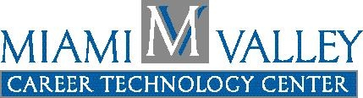

Miami Valley Career Technology Center Press Release

For Further Information Contact:
Kelly Herzog
MVCTC Public Information Coordinator
Phone - 937-854-6056
E-Mail – kherzog@mvctc.com

For Immediate Release – November 2008

MVCTC Dental Assisting Students Receive State Certification

Clayton, Ohio -- Two Dental Assisting seniors from the Miami Valley Career Technology Center (MVCTC) passed all sections of the Ohio Dental Assistant Certification test and qualified to be Certified Ohio Dental Assistants. The students are Emily Parsons CODA, from Trotwood Madison and Stephani Smeltzer CODA, from Miamisburg. These students were motivated to start early and take the October State Board examination even though it was optional. This credential will enhance their resume, allow them to perform additional skills during their employment as a dental assistant, and allows them to apply to obtain an x-ray license. Congratulations to the students and MVCTC Dental Assisting instructor, Cheryl Johnson.

A student in the MVCTC Dental Assisting Program will learn highly skilled training such as Anatomy &Physiology, laboratory skills, radiology, and office technology for an in demand career field. After completing the two-year program students would be able to pursue a career as a Dental Assistant, Dental Receptionist, or Dental Office Assistant, and with additional training could become a Certified Oral Surgeon Assistant, Dental Hygienist, or even a Dentist. For more information about the Dental Assistant Program or any of the other exciting 49 career programs offered at MVCTC, please visit www.mvctc.com.

# # #

